MC900045085[1]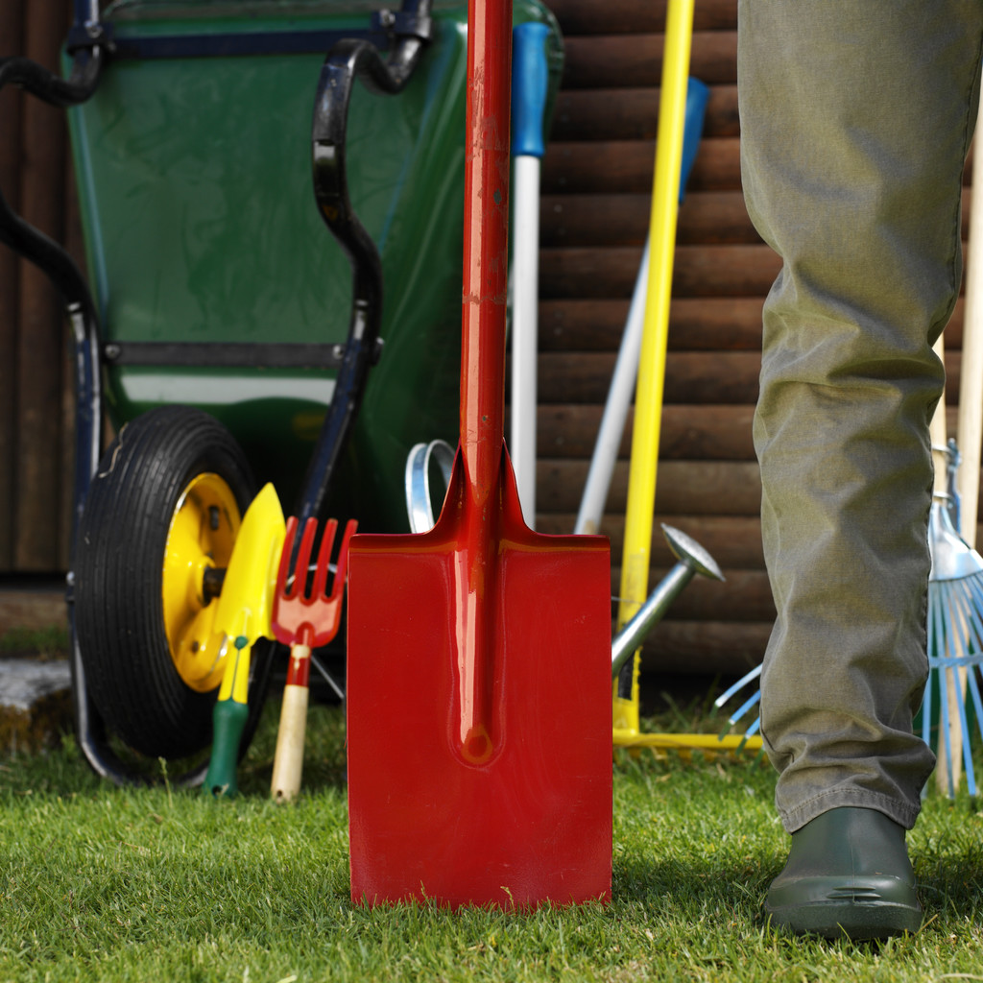MC900231877[1]

# Time for Fun in the Sun + Meet Your Neighbors!

###### More inside!

We are hosting a neighborhood party on **Wednesday, June 18 6-7:30pm**. This will be a great time to meet new people in the neighborhood and those long time residents.

The way to continue to have a safe and welcoming neighborhood is to get to know everyone in the area.

Location: High Point Park near Kottke Dr.

There will be games for all to join in and have fun:

* 3-legged Race
* Eggs on Spoon Challenge
* How Far Can You Throw
* Kids Obstacle Course

Volunteers are needed to run the games and check-in table. To get involved, please email us at: board@highlandvillagemadison.com

Please place brush at the street edge, away from mailboxes, trees and utility poles. Cover with weighted tarps to prevent items from blowing into the street and nearby yards. (if needed)

Remember to place the cut ends in the same direction.

**Brush Pick-Up**

**Week of June 2nd**

[www.highlandvillagemadison.com](http://www.highlandvillagemadison.com) • Issue #61 • Spring 2013

***Everyone is welcomed to attend!***

[Date]

**Where to see fireworks this 4th of July:**

Madison Rhythm and Booms - June 28th 9:30PM

- This year they will be displayed over Lake Monona

Elver Park Fireworks - July 3rd 9:30PM

-Make it a day at the park by bringing a picnic

Like any good party, there will be prizes!

Gift cards will be given away throughout the evening to area business – Cherry Berry, Chipotle, Subway, Starbucks and many more.

It is easy to be entered into the raffle; you simply need to attend!

At the end of the evening, we will pick three names to win one of the following $50 gift cards: Menards, Woodmans and Target. (You do not need to be present to win.)

The board will be collecting the following items to be donated to the Lussier Education Center on Gammon Road.

* Board Games
* Toilet Paper
* Birthday Candles & Gift Bags
* Batteries
* Non-perishable Food Items

Rain Date: Thursday, June 19

### Neighborhood Party cont.

Celebrate with Fireworks!

Warmer Weather means Time for Outdoor Changes

If you plan on making changes to your outdoor living area or yard, please remember to get approval from the Architectural Control Committee. This includes: decks, major landscaping, adding/removing trees, etc.   
  
Our goal is to keep our neighborhood looking beautiful and attractive.

Simply email Marcia at: [acc@highlandvillagemadison.com](mailto:acc@highlandvillagemadison.com)

***Helpful Tip***

*Contact Diggers Hotline to have your yard marked before digging. They will mark the utility lines underground.*

*Call: 8-1-1 or*

*800-242-8511*

*Visit: www.diggershotline.com*

Concerts on the Square

When: Wednesdays 7pm from

June 25th to July 30th

Where: King St. corner of the

Capitol Square

Taste of Madison

When: August 30-31

Where: Capitol Square

www.tasteofmadison.com

Brat Fest

When: May 22-26

Where: Allient Energy Center

www.brafest.com

Upcoming Area Events

A 3,000 square feet splash park will be completed August 2014. The attraction will feature interactive water spray toys and fountains for children of all ages.

The splash park is a free public facility that will be available during the summer months. This feature will be using water-conserving equipment.

For more information visit: www.cityofmadison.com/parks

Let’s Make a Splash:

New Attraction at Elver Park

#### Farmers’ Markets

Madison is known for our love of supporting local business – including farmers!

Here are a few of the closest ones:

Westside Community Market – Saturdays 7-1pm

Hill Farms DOT Parking Lot

Hilldale Farmers’s Market – Wed. & Sat. 7-1pm

Hilldale Mall behind Macy’s

Greenway Market – Thursdays 8-1pm

1650 Deming Way

Updates:

We will be discontinuing our Facebook page due to low demand. Information and updates will still be made available at:

* Nextdoor: <https://highlandvillagewi.nextdoor.com>
* Highland Village Homeowners Association: [www.highlandvillagemadison.com](http://www.highlandvillagemadison.com)

New Board Members

Matt Brink: Common Area Maintenance - He has been a resident since 2005. Matt is married with two kids.

Heather Bayens: Newsletter - I just moved in the neighborhood in January with my husband, Seth.

Friendly Reminder

• Please remember to pick up your garbage and recycle bins the same day as pick up. If you will not be home, please make arrangements for this to be done.

• Parking is not allowed in the cul-de-sacs unless designated parking spots.

Madison Ice Arena

525 Forward Drive Madison, WI

Ward 104

Alder District 1 – Lisa Subeck

District1@cityofmadison.com

Where to Vote

c/o Bayens

7309 W. Valley Ridge Drive  
Madison, WI 53719

[Address Line 1]  
[Address Line 2]  
Address Line 3]

### [Recipient]

#### Highland Village Homeowners Association